Team Number:
Time:
Rank:

SMALL BUSINESS
MANAGEMENT TEAM
(510)

PRELIMINARY
STATE – 2020

TOTAL POINTS ___________ (170)

Judges: Please double check and verify all
scores and answer keys!

Property of Business Professionals of America.
May be reproduced only for use in the Business Professionals of America
Workplace Skills Assessment Program competition.

Modification at State Preliminary Competition:
Due to his early success, Mr. Jackson has always been able to rely on word-of-mouth advertising, or allowing his products to speak for themselves. Because he started that way, he has not attempted any other type of advertising or marketing. What type of marketing should be considered in order to promote the work of ABC Graphics? How could Mr. Jackson increase his customer base?

Initial Case Study

Fred Jackson, owner of ABC Graphics, has noticed that his company has lost a significant amount of revenue over the past few years. Mr. Jackson opened his business in 2005 after graduating from a graphic design program. He is very knowledgeable in the tools used in the graphic design industry. At first, his company thrived and Mr. Jackson was the recipient of many local awards for his successful business. His success continued through 2008 where revenues plateaued and then starting in 2011 began to steadily decrease. This is depicted on the graph below.

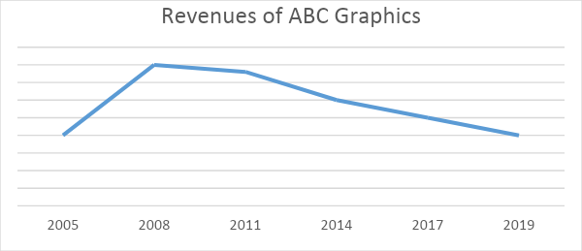

Mr. Jackson was concerned that the market had potentially become saturated and that all graphic design businesses were suffering. However, after doing some market research, there are newer companies opening, charging similar prices and are continuing to be successful. The research also showed that most organizations are still paying other companies to complete their graphic design work rather than completing it through their own employees.

ABC Graphics has on staff a salesman and an administrative assistant. Mr. Jackson completes all the graphic work himself. The salesman’s job is to find opportunities for Mr. Jackson to complete work for companies. The salesman then takes Mr. Jackson’s designs to the companies for their final approval and purchase. Mr. Jackson hired the salesman in 2008 when he noticed that sales began slowing down. The salesman has provided ample opportunity for graphics to be sold, but the final products are not being bought. Most potential clients prefer the design of a competing graphics company.

Prepare a presentation for Mr. Jackson with your suggestions for his company including, but not limited to, the questions below.

- What might be a reason that organizations are buying artwork/logos from other graphics companies and not ABC Graphics?
- What are some potential marketplace influences that could be affecting ABC Graphics’ revenue stream?
- What is the business lacking to meet the needs of an ever-changing market?
- What changes should the owner make to foster/develop future success?

Teams who do not submit an entry that follows this topic will be disqualified.

